What’s the pH?
For this exercise you will need to follow the directions on the Science with Sydney website and make a pH indicator. Found at this link: http://awarmstrong2.wixsite.com/sciencewithsydney/ph-indicator
Once you have your pH indicator you will need to look around your house and find 5 different liquid items (juice, soap, milk…).
Write you items below:
Item 1 – __________________________________________________________
Item 2 – __________________________________________________________
Item 3 – __________________________________________________________
Item 4 – __________________________________________________________
Item 5 – __________________________________________________________
Make a prediction
Do you think these things will be an acid, a base, or neutral? Circle what you think.
Item 1 - Acid Base Neutral
Item 2 - Acid Base Neutral
Item 3 - Acid Base Neutral
Item 4 - Acid Base Neutral
Item 5 - Acid Base Neutral
Do your experiment
Mix your items with the pH indicator and estimate their pH. Use the chart below to try and match the color to determine the approximate pH. Remember acids have a low pH and bases have a high pH.
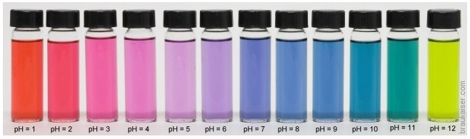
Item 1 pH = ____ Item 2 pH = ____ Item 3 pH = ____ Item 4 pH = ____ Item 5 pH = ____
Knowledge check

- The “p” in pH stands for ________________ and the “H” stands for __________________.
- Something with a pH of 2 is ______ times (more/less) _______ acidic than something with a pH of 4.
- Something with a pH of 9 is ______ times (more/less) _______ basic than something with a pH of 10.
- Acids (donate/accept) _________________ hydrogen ions (H+).
- Bases (donate/accept) _________________ hydrogen ions (H+).
- Acids have (more/less) ________________ hydrogen ions (H+).
- Bases have (more/less) ________________ hydrogen ions (H+).
- Bases tend to feel _____________.
- Acids tend to taste _____________.
- Something with a pH of _______ is considered neutral.

